Public Notice

REQUEST FOR PROPOSALS
FOR PUBLIC ELECTRIC VEHICLE CHARGING STATION INSTALLERS

Introduction
[Insert description of organization requesting proposals]

Example: Forth is a nonprofit organization with a mission to accelerate the growth and use of electric and smart transportation. We bring companies and communities together to test smart transportation technologies and business models. Our demonstration programs explore the benefits, practicality, and viability of introducing these technologies to stakeholders, with an emphasis on increasing access to underserved communities.

- Prime is requesting proposals from qualified electrical contractors to design and install number ( # ) Dual Level 2 electric vehicle (EV) charging stations at number ( # ) distinct locations in City .
- The work requires that the contractor or electrician provide proof of a C1 contractor’s license or necessary specialty license to prove their ability to legally accomplish the installation of the EV charging stations.
- Proposals are due by Time on month dd , yyyy and should be submitted to Name ( Email ), with subject line “ Project Title EVSE RFP Submittal”.
- Project Schedule and Contractor Selection

Request for Proposals Published | March 10th, 2021
End of Questions Period | March 17th, 2021
Site Walks | March 23rd, 2021
Answers to Questions Published | March 24th, 2021
Proposals Due | 7:00 PM CT April 15th, 2021
Contractor Selected | April 23rd, 2021
Project Completion Estimation | June 15th, 2021

- The right is reserved to reject any or all proposals, to waive any informality in proposals, and to accept, modify, or reject and items of the proposal.
- It is Prime's intention to review and rank proposals based upon criteria identified in the RFP and then recommend awarding a contract to the most qualified contractor.

Project Overview
The Project Title project will demonstrate a fleet of # light duty electric vehicles (EVs) and supporting infrastructure (EVSE) for use by social service agencies in a low-income community in the area that have no or little experience with these technologies. The program will deploy number ( # ) dual electric vehicle charging stations between # Social Service agencies for use by fleet drivers and community members. The vendor for these charging stations, , will deliver the charging stations to the appropriate location(s) in advance of their anticipated installation.

This project is funded by Funder and Prime , the prime recipient of the Award, is now pursuing a competitive procurement process to secure a contractor to carry-out the services described in this request for proposals. All work is subject to approval by the site hosts, Forth, Ameren, and the City of St. Louis.

Questions
Any questions concerning the solicitations and specifications shall be submitted in writing via e-mail to [Project Manager's Email] by the end of the day on month dd , yyyy . Please use subject line “ Project Title EVSE RFP”. Answers will be posted by month dd , yyyy .

Site Visits
Interested firms will have the ability to attend a site visit on month dd , yyyy at each site. It is highly recommended that interested firms attend. Each site visit will allow for 1 hour of review and Q&A.

mm/dd/yy , time - time , time zone
Host Site #1 Address

mm/dd/yy , time - time , time zone
Host Site #2 Address

Scope of Work
The scope of work includes all aspects related to the installation of charging stations at number ( # ) locations within the City of . This includes, but may not be limited to the following:

Site Feasibility and Consulting activities
- Working with Prime , site hosts, City of , contractors, and [Utility Partner] to finalize specifications and plans for each of the proposed locations
  - Provide draft site layout for each location and include quantity of charging equipment
  - Provide site plan including electrical diagram and pictures
  - Provide utility specifications
Construction, Maintenance, and other activities
- Project Management for EV Charging Station Installations
- Securing the proper permits from City of Building Division
- Working with [Utility Partner] as needed to ensure proper service connection to the charging station
- Complete application for [Utility Partner] ’s Charge Ahead EV Program
- Site preparation (utility infrastructure, boring/trenching, asphalt or concrete removal/repair, etc.)
- Furnish all labor and materials minus the charging stations themselves necessary to install and bring into service the EV charging stations
- Completing installation and related safety protocols of number (#) EVBox Dual 40-amp Level 2 charging stations
- Commissioning/Testing of new EV charging equipment to ensure proper installation and operational settings
- Coordinate access with property owner

Location of Work
All five charging stations will be installed in the City of St. Louis. Forth wishes to secure a contractor to facilitate installations at the following two sites:

- Northside Youth and Senior Service Center, 4120 Maffitt Ave, St. Louis, MO 63113.
- City Seniors, Inc., 4705 Ridgewood St., Louis, MO 63116.

Drawings entailing where at each location the charging station would be installed are included in Attachment 1 to this notice.

Note: The parking lot of Northside Youth and Senior Service Center is owned by neighboring organization, Northside Community Housing, at 4102 Maffitt Ave, St. Louis, MO, 63113. An access agreement is already in place for the installation of the charging stations to commence.

Subcontractors
Should the bidder for this request utilize the services of subcontractors, the bidder shall furnish the subcontractor company name, function that the subcontractor will perform and percent of the proposed amount for each subcontractor that the bidder intends to use. Only subcontractors identified in the bidder’s bid submittal shall be allowed to perform any work on the installation unless written approval for a new or substituted subcontractor is provided.

Compensation
Payment shall be received through check within 30 days of receiving an invoice of services performed to complete the scope of work.

Elements of proposal
1. Company profile:
a. Name of the business, contact person, and contact information: Provide
address, telephone, mobile telephone number, fax number, e-mail address, and
web address, as applicable.
b. Statement of ownership: Describe the type of business entity (sole proprietorship, corporation, LLC, or other), and list the majority and minority owners.
c. Identify MBE/WBE Participation
d. List of subcontractors. If applicable, provide company name, contact person,
address, and telephone number, and intended percentage of work to be
performed by any subcontractor.
2. Experience and ability to perform this work:
a. Describe the approach your firm would undertake to successfully complete the tasks described in the Scope of Work.
b. Description of ability and staff expertise to provide services including customer service, site evaluation, and installation.
c. Provide examples of relevant work and references. Provide the names of the organizations that contracted with you for EVSE sites. Please include the name of a contact person and phone number.
d. Provide examples of work within the City of jurisdiction.
3. Pricing:
a. Provide a schedule of fees for all relevant services described in the Scope of Work. This should take into account [Utility Partner] ’s Charge Ahead EV incentive program.
4. Schedule:
a. Provide a tentative work plan and schedule for work for be completed.

Evaluation Criteria
Prime will conduct a comprehensive, fair and impartial evaluation of all Proposals received in response to this RFP. Each Proposal will be analyzed to determine overall responsiveness and qualifications under the RFP. Criteria to be evaluated may include the items listed below. Additional information may be requested from Firms at any time prior to final approval of a selected Firm. A 50-point scale will be used to evaluate eligible proposal applications. Scores will be used to develop final recommendations. Proposal applications will be evaluated and ranked according to the following criteria:

Criteria | Points available
Financial viability: Cost effectiveness is based on applicant provided budget | 20
Conformance to Scope  - Shown ability to complete requested scope of consulting and installation  - Ability to complete work within provided schedule | 15
Project Team Experience and Qualifications  - Current and past vendor performance in customer service, commercial acumen, public service  - Experience within the jurisdiction  - MBE/WBE vendors and subcontractors – priority given | 15
Total | 50

Attachment 1
- Host Site #1 Name , Host Site #1 Address .

[Insert image of host site]

Example:

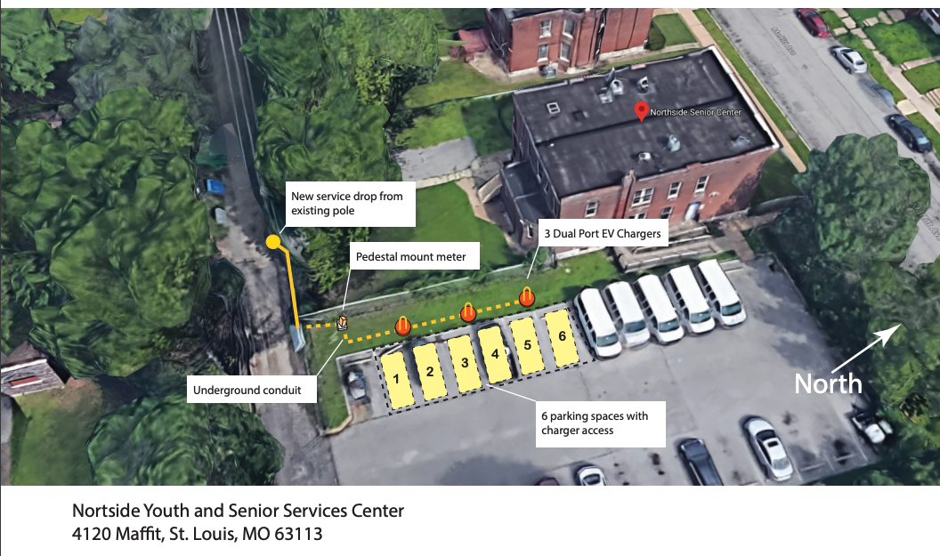

- Host Site #2 Name , Host Site #2 Address .

[Insert image of host site]

Example:

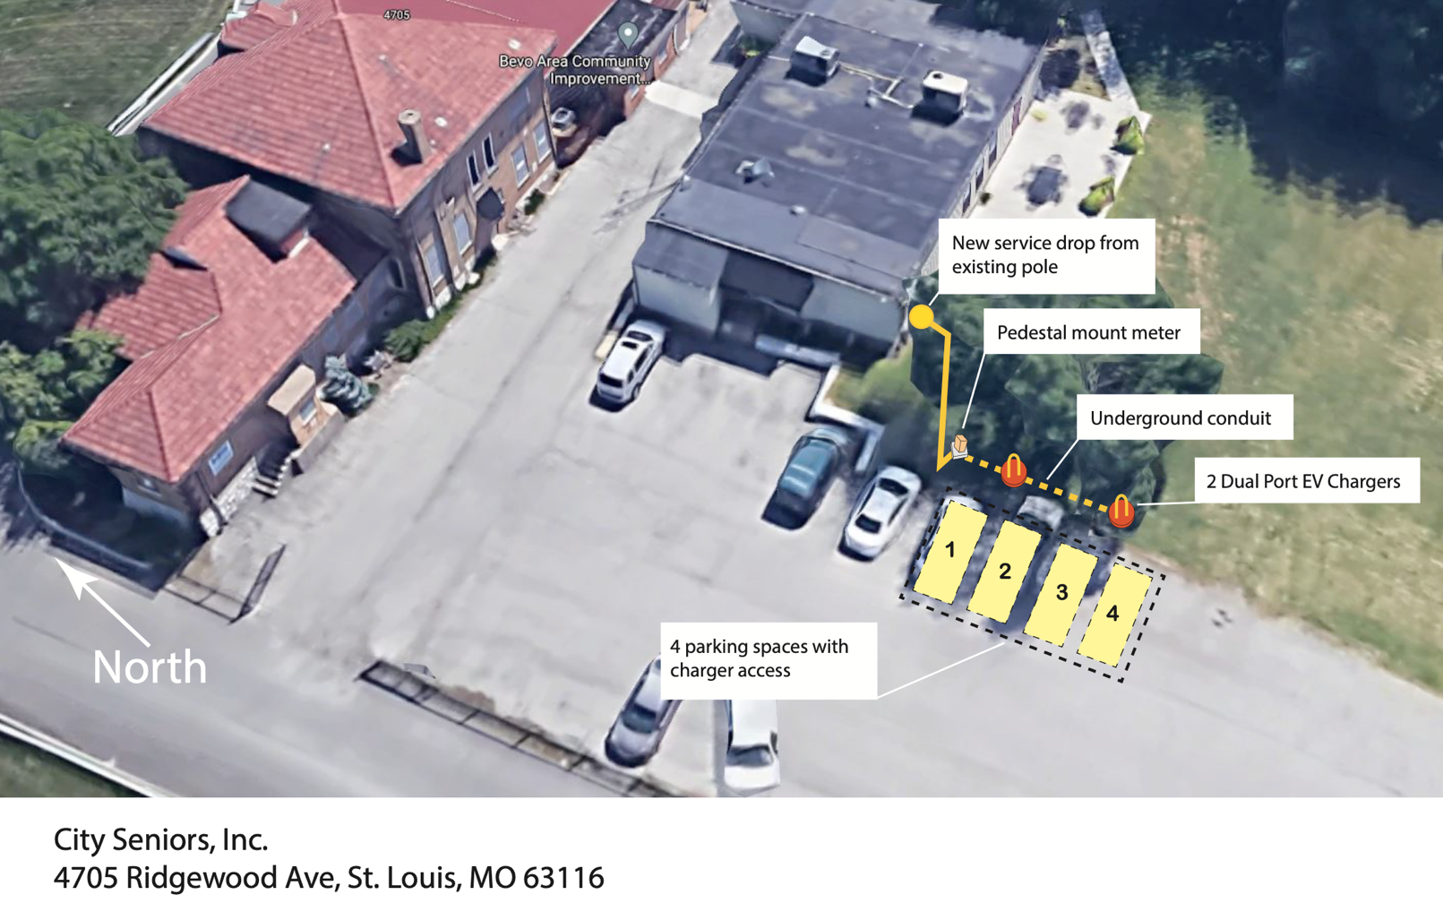

Attachment 2
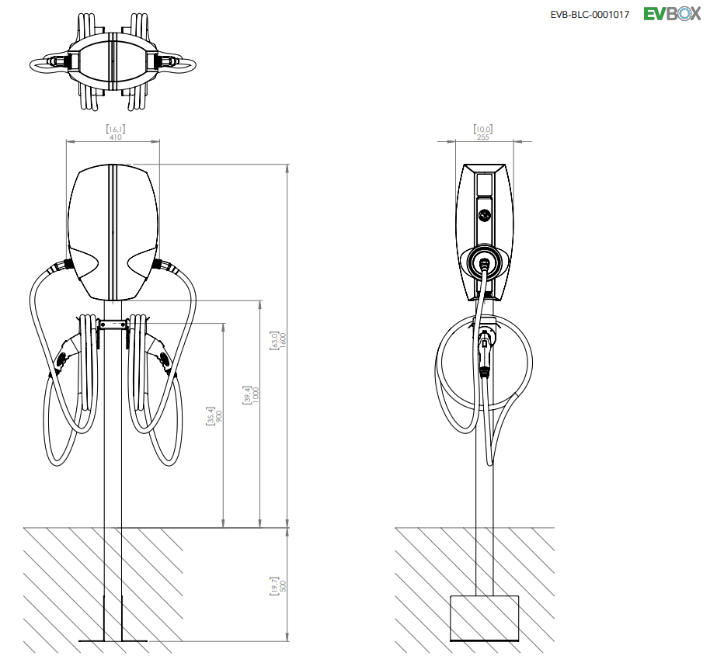

Dual Level 2 Charger from EVBox BuisnessLine
Datasheet available here: https://evbox.com/us-en/businessline

